EGER GRAND PRIX 2012

EVENT BULLETIN - 2

Registration
On 27.10 at the finish area (event center), from 08:00 till 9:30 am.
Entries during the event shall be accepted only to vacant places and shall be charged with extra fee, because there will be no possibilities to print extra maps.

Event places

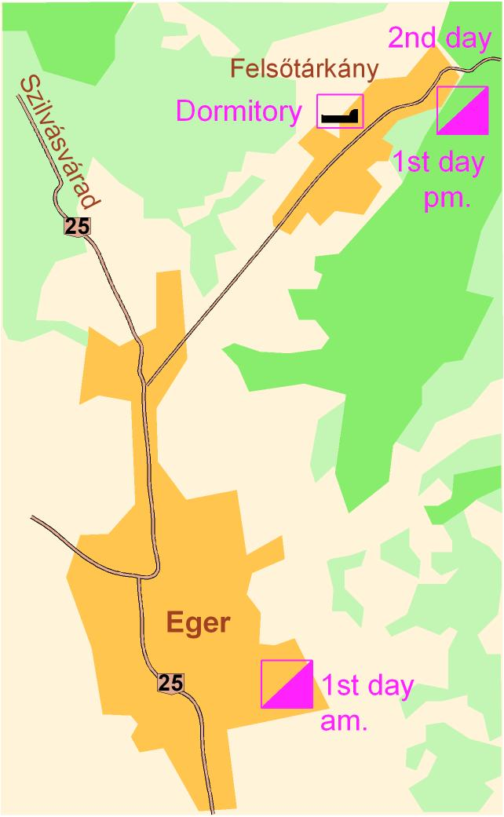

Event president Attila Blézer
Courses 1st.day: am. Csongor Kali pm. Imre Veres
2nd.day: Imre Veres and Judit Lakó
Controllers 1st day am. Zsolt Kuzman
1st.day pm and 2nd day János Sümegi
Sportident/office Zoltán Fekete
Start Gábor Berecz
Finish Sándor Csécs
Doctor Miklós Kincses
Child competition Ágnes Csák

Parking
1st.day am:
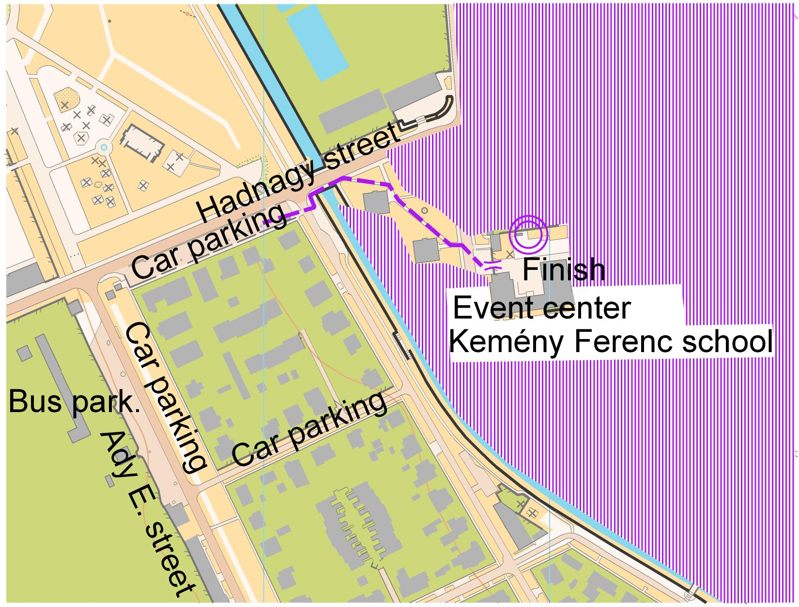

1st.day pm and 2nd.day
Finish – Felsőtárkány village, Imó-kő camp. Parking at the camp, and in Felsőtárkány, besides of the football area.

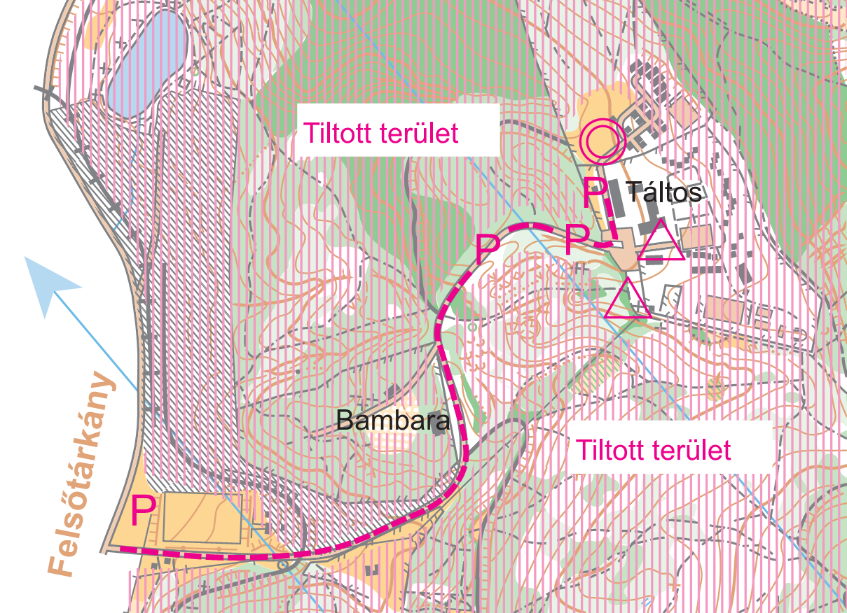

Maps:
1st day am: 1:4000/2,5m corrected in 2012-ben, little map: 1:1000!
1st day pm: 1:5000/5m corrected in 2012
2nd.day: F/M and N/W 16-35 1:15000/5m, all other categories 1:10000/5m, corrected in 2012

Contol descriptions printed on the map, additional control descriptions are provided at the start area on
both days.
All map size A4, printed on waterproof paper. Maps have to be collected till the last start of every race.

Terrrain
1st day am: Eger downtown. Running shoe (without studs and spikes) is recommended.
1st day pm: park forest, there are many paths.
2nd day: middle-height terrain, sometimes with steep slopes,clear forests and bushes can be found here.

Forbidden areas, roads:
1st day am. and 2nd day: The fisinsh areas and the parking areas next to the finish.
The road leading to the finish from Felsőtárkány - parking is prohibited, as well as in populated areas, and in some parts of the Bambara Hotel.

New categories
Coaches will request F/M 12D és N/W 12D

Startlists
Complete startlist can be found in the event center, and the start places.

Results
The daily and summary results can be viewed during the competition at the finish continously (15-20 min)

Refreshing point
On a 2nd day, in categories: F/M 21A, F/M 21B, F/M 35A

SPORTident
The competition is organized with SPORTident electronic punching system.
In case of failure of the SI box, please use the traditional puncher and inform it at the finish.

First start
1st day am: 10:00 1st day pm: 14:30 2nd day: 10:00

Distances, marked routes

 | 1st day am. | 1st.day pm. | 2nd day | colour
Parking – Finish | 100-500m | 100-1000m | 100-1000m | white
Finish - Start | 1200 m | 100m | 200m | white-blue

Planned prize-giving ceremony

The first three of each class will be awarded medals prizes based on the total result of the two competition days. We no awarded the open categories.

1st.day am - important informations!
The start will be near a street with heavy traffic. The mark (ribbon) of the road between the event center and the start will be on streets of Eger too. Please pay attention to the traffic. The scale of the map is 1:4000. The map will contain a magnified cut (1:1000) of the eastern part of the school-playground map. This cut will be at the bottom of the A4 size map. This part of the playground involves a labyrinth. Between the territories separated by ribbons You can move only via the empty, penetrable areas. The cordons will be marked as impassable fence! It is forbidden to cross the impassable fence and the cordons. Competitors violating this rule will be disqualified! The labyrinth doesn't affect the 10D, 10DK, 12C, 14C, 15-18C, 21C, OB categories. The tracks cross roads with serious traffic. You can cross these streets at the crossing points signed on the map! The crossing at these points will be helped by civic guard. We ask the trainers to call the tanítvány's attention to this hazard. We ask all of you to take care of your health!

Others:
- At the finish buffet is available, for the racers refreshments will be provided.
- For the children competition you can register at the finish and it is free of charge.
- Dr. Miklós Kincses is the doctor of the competition and he will be in the finish area on both days.
- All commercial activities at the finish are allowed only with the permission of the organizers.
- Every competitor are requested to punch at the finish. If You are lost, the finish can be reached through the following mobile phone number: +36 70 3170095.

Everyone starts at the competition at his/her own responsibility!
We wish you a good competition!

  Eger city 

Felsőtárkány village 