2 4th. E G E R G R A N D P R I X 1 0. 2 7 – 2 8 . 2 0 1 2 – B U L L E T I N 1.

Organizer: Egri Spartacus Orienteering Sport Club H-3300 Eger, Zellervár u.3

Competition: 1st day – middle distance, 2nd day - long distance, individual orienteering event.

Location: 1st day am - Eger – downtown, pm – Felsőtárkány village, 2nd day Bükk mountain, Felsőtárkány village

President: Attila Blézer
Course setting: 1st day : am - Csongor Kali, pm - Imre Veres 2nd day: Imre Veres, Judit Lakó
Controller: 1st day: János Sümegi 2nd day: János Sümegi

Terrain: 1st day am – town, with asphalt roads, small zigzag streets, parks.
1st day pm – easy running wooded parkland, little elevation, dense road network.
2nd day – mountain of medium height land, in some places steep slopes. The road network is dense in some places. There are easy running forests and undergrowths
too. Several parts of the competition area is new, orienteering map of these terrains has not been made yet.

Maps: 1st day, am - scale 1:5000/2,5m corrected in 2012, pm – 1:5000/5m, 2nd day scale 1:15000/5m and 1:10000/5m, corrected in 2012.

SPORTident: the competition is organized with the SI system. Competitors having own SI cards are kindly requested to write the numbers of their cards on the entry forms! Rental fee of SI card is 200.-HUF/day.

Entries: deadline: October 10. 2012

Entry address:  Fekete Zoltán H-3395 Demjén, Széchenyi u. 47 online: http://entry.mtfsz.hu (recommended) e-mail: egrispartacus@atw.hu (name, category, SI number) In case you do not get a receipt confirmation of your electronic entry within 24 hours please repeat sending it.

Entry fees:
 | W / M 16-55 | W / M 10-14; 60- | OPEN
till 10. 10 | 3.600/3 race 1.200 HUF/race | 3.600 HUF/3 race  1.200 HUF/race | 2.400 HUF/3 race  800 HUF/race
till 27. 10 | 5.400/3 race 1.800 HUF/race | 3.600 HUF/3 race  1.200 HUF/race | 2.400 HUF/3 race  800 HUF/race
at the event | 7.200/3 race 2.400 HUF/race | 3.600 HUF/3 race  1.200 HUF/race | 2.400 HUF/3 race  800 HUF/race
Kids can enter the child competition at the finish and it is free of charge.
Payment can be in cash at the registration, or by bank transfer to the following account number:
Address: Egri Spartacus SE H-3300 Eger, Zellervár u.3
Bank: K&H Bank Zrt.
Swift/BIC: OKHBHUHB
Account number: 10403507 00003639 00000003
IBAN: HU11 1040 3507 0000 3639 0000 0003
Details of payment: Eger Grand Prix 2012
In case of bank transfer at the registration you are kindly requested to show the confirmation slip of your transfer!

Classes:
M/W- 10D (marked), 10DK (with parent), 12C, 14B,C 16B, 18B, 15-18C, 20E, 21A,B,Br, (B-short) C, 35A,Br, 40B, 45B, 50B, 55B, 60B, 65B, 70B, 75B, 80B
OB (open beginner), OT (open technical), child competition. In case of having less than 5 participants classes may be merged.

Planned start times: 1st. day 10:00 am, 14:00 pm. 2nd. day 10:00 am.

Accomodations in Felsőrárkány:
Bambara Hotel Park Hotel Táltos
Primary school, with own gears 800.-HUF/person/night
Other accomodation should be arranged individually. (Tourinform-Eger tel: 00 36 36 517715 e-mail: eger@tourinform.hu)

Transport: will not be organized, the competition can be approached by local public transport.

Prizes: The first three runners of each class will be awarded a medal, based on the total result of the 3 competition races.

Important informations on the first day: Running shoe (without studs and spikes) is recommended.

Others:
- Competitors will be given refreshment at the finish area after the race. There will be buffet at the finish.
- All competitors who started should report at the finish area.
- Sales of orienteering and other sports equipment as well as any sales activities are only allowed with the agreement and permission of the organizers.

Information: www.egrispartacus.atw.hu , egrispartacus@atw.hu

  Eger Megyei Jogú Város 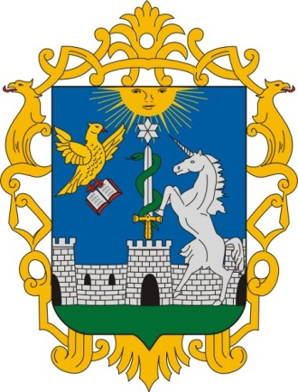 Felsőtárkány 